**JAVA ASSIGNMENT -5**

**1. Create a class Student with 2 data members’ rno and name. Create one method setData() that takes roll number and student name as parameter and stores them in data members rno and name. Create one more method showData() to print the data member values. Create another class ( main class) StudentDemo that creates Student class object and calls setData() and**

**showData() methods**.

class Student{

int rollNo;

String name;

void setData(int rollNo, String name){

this.rollNo=rollNo;

this.name=name;

}

void showData(){

System.out.println(rollNo+" "+name);

}

}

class StudentDemo{

public static void main(String args[]){

Student s = new Student();

s.setData(1,"ELON MUSK");

s.showData();

}

}

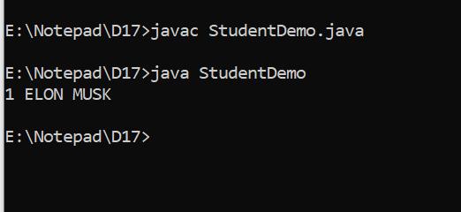

**2. Modify the above program (no. 31) to count the no of Student objects created.**

**[ In this program static variable is required ]**

class Student{

int rollNo;

String name;

static int noOfObjects = 0;

Student(){

noOfObjects += 1;

}

void setData(int rollNo, String name){

this.rollNo=rollNo;

this.name=name;

}

void showData(){

System.out.println(rollNo+" "+name);

}

}

class StudentDemo{

public static void main(String args[]){

Student s = new Student();

s.setData(1,"ELON MUSK");

s.showData();

Student s1 = new Student();

s1.setData(2,"RATAN TATA");

s1.showData();

System.out.println("COUNT=");

System.out.println(s.noOfObjects);

}

}

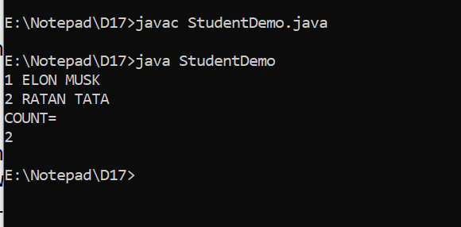

**3. Write a program to demonstrate functionalities of this keyword in java.**

class Student{

int rollNo;

String name;

static int noOfObjects = 0;

Student(){

noOfObjects += 1;

}

void setData(int rollNo, String name){

this.rollNo=rollNo;

this.name=name;

}

void setDatawithoutthis(int rollNo, String name){

rollNo=rollNo;

name=name;

}

void showData(){

System.out.println(rollNo+" "+name);

}

}

class StudentDemo1{

public static void main(String args[]){

Student s = new Student();

s.setData(1,"ELON MUSK");

s.showData();

Student s1 = new Student();

s1.setData(2,"RATAN TATA");

s1.setDatawithoutthis(5,"this");

s1.showData();

System.out.println("COUNT=");

System.out.println(s.noOfObjects);

}

}

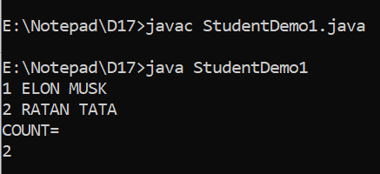

**4. Create a class Circle that has two data members, one to store the radius and**

**another to store area and three methods first init() method to input radius from**

**user, second calculateArea() method to calculate area of circle and third**

**display() method to display values of radius and area. Create class**

**CircleDemo ( main class) that creates the Circle object and calls init(),**

**calculateArea() and display() methods.**

import java.util.*;

class Circle {

int radius=0;

double pi = 3.14, area=0;

public void init(int i)

{

radius=i;

}

public void calculateArea( )

{

area = pi * radius * radius;

}

void display()

{

System.out.println("the radius entered by user is: " +radius);

System.out.println("Area of circle:"+area);

}

}

class CircleDemo{

public static void main(String args[])

{

int rad = 0;

Scanner s = new Scanner(System.in);

System.out.println("Enter the radius");

rad =s.nextInt();

Circle ci = new Circle();

ci.init(rad);

ci.calculateArea();

ci.display();

}

}

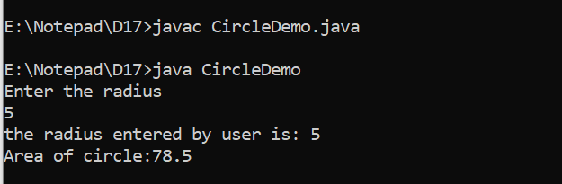

**5. Create a class MathOperation that has four static methods. add() method that**

**takes two integer numbers as parameter and returns the sum of the numbers.**

**subtract() method that takes two integer numbers as parameter and returns**

**the difference of the numbers. multiply() method that takes two integer**

**numbers as parameter and returns the product. power() method that takes**

**two integer numbers as parameter and returns the power of first number to**

**second number. Create another class Demo (main class) that takes the two**

**numbers from the user and calls all four methods of MathOperation class by**

**providing entered numbers and prints the return values of every method.**

import java.util.Scanner;

class Demo

{

public static void main(String[] args)

{

int n1 = 0, n2 = 0;

int a = 0, s = 0, m = 0, p = 0;

Scanner sc = new Scanner(System.in);

System.out.println("Enter two Numbers for operation: ");

n1 = sc.nextInt();

n2 = sc.nextInt();

a = MathOperation.addX(n1,n2);

s = MathOperation.subtractX(n1,n2);

m = MathOperation.multiplyX(n1,n2);

p = MathOperation.powerX(n1,n2);

System.out.println("Sum of two numbers is: " +a);

System.out.println("Difference of two numbers is: " +s);

System.out.println("Product of two numbers is: " +m);

System.out.println("Power of n1 raise to n2 is: " +p);

}

}

class MathOperation

{

static int addX(int n1, int n2)

{

int sum = (n1 + n2);

return sum;

}

static int subtractX(int n1, int n2)

{

int diff = (n1 - n2);

return diff;

}

static int multiplyX(int n1, int n2)

{

int productX = (n1*n2);

return productX;

}

static int powerX(int n1, int n2)

{

int i = 0, ians = 1;

for(i = 1; i <= n2; i++)

{

ians = (ians * n1);

}

return ians;

}

}

